IL Activities for the Week of
June 13th-19th, 2022
Schedule is subject to change at any time
You must sign-up for any Activity with an *

Mon. June 13th: National Weed Your Garden Day
9:00 AM Chair Exercises- TV Ch. 718
9:00 AM Coffee Group-Rec. Rm.
10:00 AM *New Dollar Tree/Family Dollar in Martinsburg-Bus
10:30 AM Pool Aerobics/Stretching-Pool
11:00 AM Water Volleyball-Pool
1:00 PM Bible Study-Library
2:00 PM *Cognitive Fitness-Library
3:00 PM Bingo-Cafe
6:00 PM Card Playing-Library
7:00 PM Billiards-3rd floor SV Billiards Rm.

Tues. June 14th: National Flag Day
9:00 AM Homeward Bound Vintage Music-TV Ch. 718
9:30 AM *Grocery Shopping-Giant Eagle
9:30 AM Cardio, Weights & Bands-LGR
10:15 AM Yoga-LGR
11:00 AM Chair Exercises-LGR
11:30 AM Gentle Stretching-LGR
1-3:00 PM Bocce: Team 2 vs Team 5
1-4:00 PM Ice Cream Truck on Campus
2:00 PM Patriotic Sing-A-Long with Betty Moudy-Great Room
3:30 PM Chair Exercises-TV Ch. 718

Wed. June 15th: National Photography Day
8:30 AM *Trip to Bellville, Pa
1:30 PM Movie: “Dog”-GCC & Ch. 718
3:00 PM Reader’s Club-Library
6:30 PM Shuffleboard-outdoor court

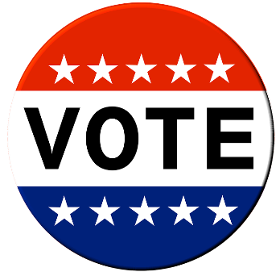
Thur. June 16^{th:} National Nurse Assistants’ Day
10:30 AM Pool Aerobics & Stretching-Pool
11:00 AM Water Volleyball-Pool
12:00 PM *Jam Session at Blue Knob Firehall w/ Dave Replogle & Friends-Bus
1:00 PM Scrabble-2nd floor lounge SV
3:30 PM Chair Exercises-TV Ch. 718
6:30 PM Pinochle-Café
7:00 PM Billiards-3rd Floor SV Billiards Rm.
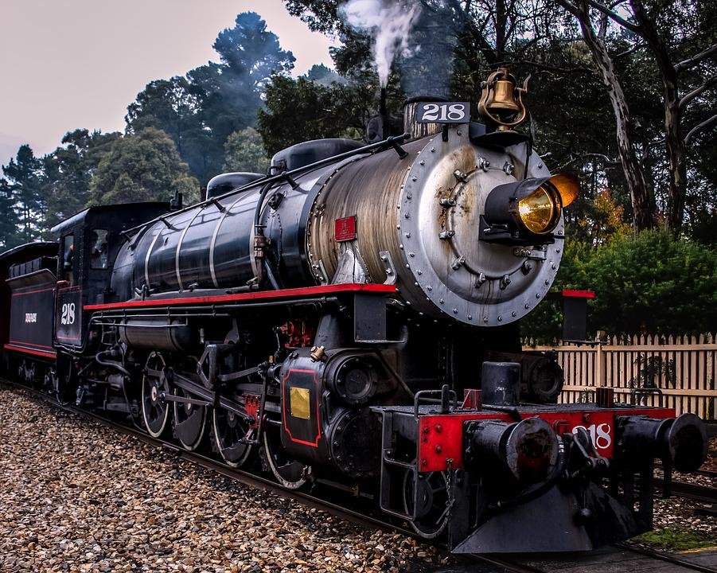

Fri. June 17th: National Flip Flop Day
9:00 AM Chair Exercises-TV Ch. 718
9:00 AM *Frostburg Flyer Trip-Bus
4:00 PM *Terrace Hour-Cafe
6:00 PM Card Playing-Library
7:00 PM Billiards -3rd floor SV Billiards Rm.
Sat. June 18th: National Go Fishing Day
10:00 AM Table Tennis-LGR
10:00 AM “Busy Fingers”-Great Room
11:00 AM Recreation Games-LGR
3:00 PM 15 min Stretching-Ch. 718
3:00 PM Card Playing-Library

Sun. June 19th: Father’s Day
10:30 AM Church Services-Chapel
3:00 PM 15 min. Stretching-Ch. 718
3:00 PM Card Playing-Library

UPCOMING EVENTS:
June 21st: 1st Day of Summer Cocktail Party
June 23rd: Mini Golf
June 24th: Huntingdon County Arts Center
June 27th: Julie Nevel
June 28th: Altoona Curve Game
June 29th: Prelude Technical Presentation; Altoona Community Band

