IL Activities for the Week of
May 16th-22nd, 2022
Schedule is subject to change at any time
You must sign-up for any Activity with an *

Mon. May 16th: Do Something Good for Your Neighbor Day
9:00 AM Chair Exercises-TV Ch. 718
9:00 AM Coffee Group-Rec. Rm.
10:30 AM Pool Aerobics-Pool
11:00 AM Water Volleyball-Pool
1:00 PM Bible Study-Library
2:00 PM *Cognitive Fitness-Library
3:00 PM Bingo-Cafe
6:00 PM Card Playing-Library
7:00 PM Billiards-3rd floor SV Billiard’s Rm.

Tues. May 17^{th:} National Cherry Cobbler Day
9:00 AM Vintage Springtime Music-TV Ch. 718
9:30 AM *Grocery Shopping-Saxton Market
9:30 AM Cardio, Weights & Bands-LGR
10:15 AM Yoga-LGR
11:00 AM Chair Exercises-LGR
11:30 AM Gentle Stretching-LGR
1-3:00 PM Bocce: Team 1 vs Team 2
2:00 PM *Chatty Chicks-café Patio ($2)
2:30 PM Diabetes Support Group-Library
3:30 PM Chair Exercises-TV Ch. 718

Wed. May 18^{th:} National Visit your Relatives Day
10:30 AM Pool Aerobics-Pool
11:00 AM Water Volleyball-Pool
12:30-2 PM *Booster Clinic-HCC
1:30 PM Movie: “A Simple Twist of Fate”-TV CH. 718
1:00 PM *Quarterly Birthday Party-Cafe
3:00 PM Reader’s Club-Library

Thur. May 19^{th:} National Devil’s Food Cake Day
11:00 AM *Retired School Teachers Luncheon-GCC
1:00 PM Scrabble-2nd floor lounge SV
1:30 PM Spelling Bee-Rec. Rm.

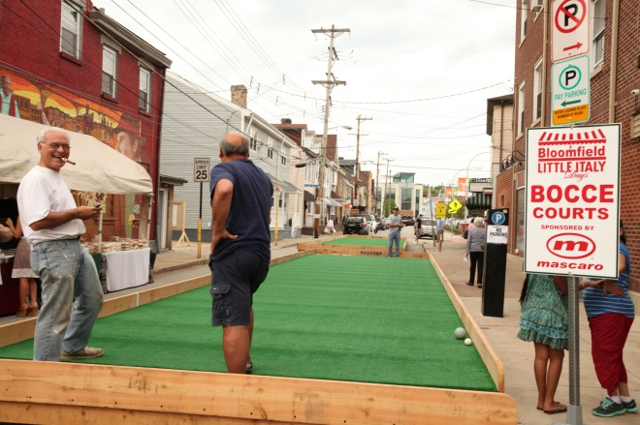

(Thurs May 19th con’t.)
3:30 PM Chair Exercises-TV Ch. 718
3:30 PM Choir Practice-Chapel
6:30 PM Pinochle-Café
7:00 PM Billiards-3rd floor SV Billiard’s Rm

Fri. May 20th: National Rescue Dog Day
8:00 AM *Trip to Doolittle Center, Dubois
8:30 AM Massages by Ashley-Massage Rm.
9:00 AM Chair Exercises-TV Ch. 718
4:00 PM *Terrace Hour-Cafe
6:00 PM Card Playing-Library
7:00 PM Billiards -3rd floor SV Billiard’s Rm.

Sat. May 21st: National Waitstaff Day
10:00 AM Men’s Table Tennis-LGR
10:00 AM “Busy Fingers”-Great Room
11:00 AM Women’s table tennis-LGR
3:00 PM 15 min Stretching-Ch. 718
3:00 PM Card Playing-Library

Sun. May 22nd: National Solitaire Day
10:30 AM Church Services-Chapel
3:00 PM 15 min. Stretching-Ch. 718
3:00 PM Card Playing-Library

UPCOMING EVENTS:
May 23rd: Evening cello Concert
May 26th: Olde Bedford Brewing Co. on campus
May 27th: The Hoppers
May 31st: Greenhouse Crawl

