IL Activities for the Week of
June 27th- July 3rd 2022
Schedule is subject to change at any time
You must sign-up for any Activity with an *

Mon. June 27th: National Ice Cream Cake Day
9:00 AM Chair Exercises- TV Ch. 718
9:00 AM Coffee Group-Rec. Rm.
9:45 AM Gentle Stretching-LGR
10:30 AM Pool Aerobics/Stretching-Pool
11:00 AM Water Volleyball-Pool
1:00 PM Bible Study
2:00 PM *Cognitive Fitness-Library
3:00 PM Music-Julie Nevel-GCC
6:00 PM Card Playing-Library
7:00 PM Billiards-3rd floor SV Billiards Rm.

Tues. June 28th: National Paul Bunyan Day
9:00 AM Sentimental Summer Music-Ch. 718
9:30 AM *Grocery Shopping-Giant Eagle
9:30 AM Cardio, Weights & Bands-LGR
10:15 AM Yoga-LGR
11:00 AM Chair Exercises-LGR
1-3:00 PM Bocce: Team 1 vs Team 5
2:00 PM *Watermelon Craft-Rec. Rm. ($2)
3:30 PM Chair Exercises-TV Ch. 718
5:00 PM *Leave for Curve Game-Bus

Wed. June 29th: National Parchment Day
9:30 AM Walking Club-off campus
10:00 AM Cornhole-Outdoor courts
1:00 PM *Prelude Seminar-GCC
2:00 PM Nutrition-Library
6:30 PM Altoona Community Band-GCC
6:30 PM Shuffleboard-outdoor court

Thur. June 30th: National Handshake Day
9:45 AM Gentle Stretching-LGR
10:00 AM Campus Stroll-SV Entrance
10:30 AM Pool Aerobics & Stretching-Pool
11:00 AM Water Volleyball-Pool
1:00 PM Scrabble-2nd floor lounge SV
2:00 PM *Men’s Snack & Yak-Café Patio ($2)
3:30 PM Chair Exercises-TV Ch. 718
6:30 PM Pinochle-Café
7:00 PM Billiards-3rd Floor SV Billiards Rm.
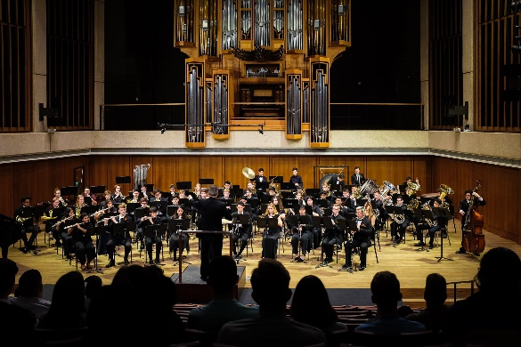

Fri. July 1st: National Postal Worker Day
9:00 AM Chair Exercises-TV Ch. 718
10:00 AM Dominoes-Rec. Rm.
2:00 PM *4th of July Trivia & Treat-Café Patio
4:00 PM *Terrace Hour-Cafe
6:00 PM Card Playing-Library
6:30 PM *Jim Worthing Concert-GCC & Ch. 718
7:00 PM Billiards -3rd floor SV Billiards Rm.
Sat. July 2nd: Hop-A-Park Day
10:00 AM Table Tennis-LGR
10:00 AM “Busy Fingers”-Great Room
3:00 PM 15 min Stretching-Ch. 718
3:00 PM Card Playing-Library

Sun. July 3rd: National Eat Your Beans Day
10:30 AM Church Services-Chapel
3:00 PM 15 min. Stretching-Ch. 718
3:00 PM Card Playing-Library

UPCOMING EVENTS:
July 6th: Afternoon at Canoe Creek
July 7th: shopping at Logan Town Center
July 8th: trip to Coverlet Museum & lunch
July 11th: Auxiliary Fundraiser Meal at Hoss’s
July 12th: Ice Cream Truck on Campus
July 13th: IL Picnic
July 14th: Whipples Dam & lunch

